

**DEDAN KIMATHI UNIVERSITY OF TECHNOLOGY**

**SCHOOL OF ENGINEERING**

**DEPARTMENT OF MECHATRONICS ENGINEERING**

1. **ONYUNA AGGREY OMONDI E022-01-0747/2017**
2. **NAFULA FAITH E022-01-0749/2017**
3. **ADEGU GLORIA VUHYA E022-01-0737/2017**
4. **ISAAC MWONDI VENANT E022-01-0726/2017**

**TITLE: STUDY AND DEVELOPMENT OF AN AUTOMATED DRILL**

A project proposal submitted in partial fulfillment of the requirement for the award of the Degree of Bachelor of science in Mechatronic Engineering in the Dedan Kimathi University of Technology.

**FEBRUARY 2022**

# ACKNOWLEDGEMENT

We would like to thank the almighty God for gift of life and good health during the preparation of this research undertaking. Our heartfelt gratitude also goes to our able supervisor Dr. Titus Mulembo, who we have worked closely with in preparation and undertaking of this research. We also wish to acknowledge the entire Department of Mechatronic Engineering of Dedan Kimathi University of Technology for the support they have given us during this process. To our colleagues, friends and parents who gave us support in any manner, we are grateful indeed.

**ABSTRACT**

Acrylic polymers and co-polymers are currently widely used in industry in all kinds of applications due to their chemical purity, stability, high heat resistance, sunlight resistance, excellent weathering, low-temperature performance, water resistance, and hydrophobicity. Acrylic is very scratch resistant compared to other transparent plastics. It is a lighter alternative to glass and an

economical substitute for polycarbonate in applications where strength is not crucial.

Due to its wide applications, various manufacturing processes are performed on acrylic, drilling one of them. Drilled holes can be produced on the acrylic using conventional or non-conventional drilling processes. Conventional micro-drilling uses drill bits of different configurations such as twist, spade, D-shaped, single flute, compound drill, and coated micro drill. In contrast, non-conventional micro-drilling involves electrical, chemical, mechanical, and thermal means, including laser, EDM, ECM, SACE, electron beam, ultrasonic vibration, or combinations of these approaches.

Various researchers and manufacturing companies working with PMMA have proposed different guidelines for drilling PMMA. The spindle speed, feed rate, tool point angle, coolant & lubricating agent, vibration, tool material, clearance, and chip length influences the drilling process. These machining parameters must be optimized in order to produce quality holes and maintain the material properties of the machined workpiece for long service life

The current work focuses on developing an automated drilling machine that measures the drilling parameters required for drilling different hole sizes on PMMA.

© 2017 The Authors. Published by Elsevier B.V.

Peer-review under responsibility of the scientific committee of The 50th CIRP Conference on Manufacturing Systems.

## INTRODUCTION

**PROBLEM STATEMENT**

Current automatic CNC machines used to drill PMMA are expensive. In addition, the alternatives used, such as the hand drill, are frequently marred by drill bit breakage, mainly inexperienced users. On the other hand, if the workpiece or drill-bit is not tightly held, walking phenomena occur where the drill bit tends to skid away from the desired drilling coordinates giving a significant blow to the precision of drilled holes.

There is a need to develop an inexpensive automated drilling machine that addresses all these challenges. In contrast with the available CNC drilling machines, the proposed automated drill has the advantages of lower cost, less construction difficulty, and maintenance that is more convenient. It is also a more straightforward use; hence, it produces quality and curbing bit breakage for thin drill bits and drill bit wear for thick drill bits.

**JUSTIFICATION**

Currently, the drilling of PMMA is by using automatic CNC machines. However, this method has proved to be expensive, and its availability to the ordinary person is limited.

The other alternative used is the hand drill frequently marred by the drill bit breakage, primarily inexperienced users. On the other hand, if the workpiece or drill bit is not tightly held, a walking phenomenon occurs where the drill bit tends to skid away from the desired drilling coordinates giving a significant blow to the precision of the drilled holes.

The automated drill finds it suitable for PMMA drilling because it is less expensive. Therefore, it saves on costs has high accuracy and precision. In addition, this production of quality drill holes and the machining parameters are continuously monitored and optimized for the entirety of the drilling process, thus saving time.

In contrast with the available CNC drilling machines, the proposed automated drill will have the advantages of lower costs, less construction difficulty, more convenient maintenance, and simpler to use, hence producing quality and curbing bit breakage for thin drill bit wear for thick drill bits.

In the recent past, we have seen a tremendous rise in the use and application of acrylic polymers. From the aerospace industry to the entertainment industry, PMMA is being used for various purposes, leading to various manufacturing processes, including drilling.

The automated drill finds its suitability in PMMA drilling because it is less expensive has high accuracy and precision. The machining parameters are automatically monitored and optimized for the entirety of the drilling process. In addition, the machine uses the peck cycle drilling, where the workpiece is drilled intermittently, for adequacy.

## OBJECTIVES.

### Main Objective.

To design and fabricate an automated drilling machine for PMMA drilling.

**Specific Objectives**

## To design and fabricate an automated drilling machine.

## To design mechanical assembly simulations using CAD software.

## To design an electrical circuit that interfaces with the sensors during the drilling operation.

## To monitor force, thermal fluctuations, and optical characterization

## To enable drilling of quality, thin/long holes.

## To design optimal machining conditions for drilling of PMMA (polymethyl methacrylate).

## PROJECT SCOPE

As outlined above, our project will mainly focus on designing and fabricating an automated drill that ensures drilling of quality thin, long holes while monitoring parameters such as temperature and vibrations to determine optimum drilling parameters.

1. **METHODS**

In order to achieve quality drilling of holes using optimum conditions such as the feed rate, drilling speed, and drill bit diameter, we had to follow the required steps as follows:

1. Coming up with CAD Models and electrical circuits using softwares: achieved through Solidworks, Proteus, Fritzing
2. Simulations of the whole system and its components using Simscape, Proteus, Abaqus: Simulations that show how the system would move prior to fabrication, temperature and force simulations of the workpiece and simulations of the electric components too.
3. Actual fabrication of the rig: Assembly of all the mechanical parts. Processes included welding, woodcutting, bolting, painting
4. Circuit interfacing of the sensors, actuators and drivers and their programming:
5. Running the experiments and data collection and observation to determine the optimum parameters: Running the motors sequentially to approach the workpiece, drill the PMMA while sensors are collecting data then move back to the original position.

**Experimental Rig**

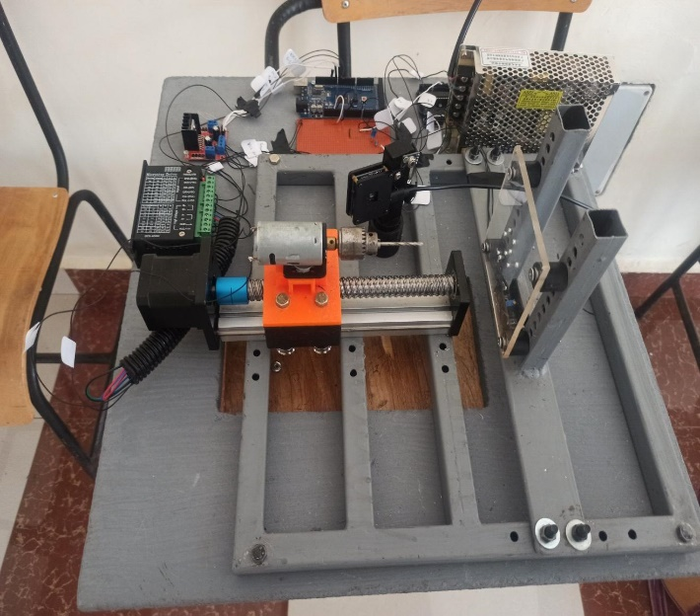

Figure 1: an image of the whole assembly

**Components**

* NEMA 17 Stepper motor.
* DC Motor.
* 801S Vibration sensor module.
* MLX0614 non-contact Infrared temperature sensor.
* TB6600 Microstep stepper motor driver.
* L298N DC motor driver.
* Arduino Mega

**Procedure**

This involved drilling with drill bits of different diameters while varying their feed rates until the optimum parameters were identified.

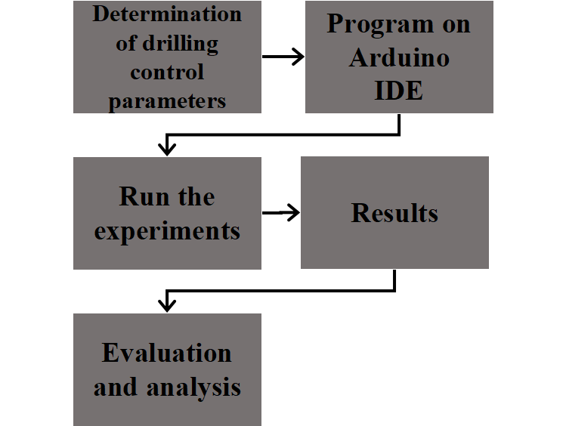

1. **EXPERIMENTAL RESULTS**

**Temperature from MLX90614**

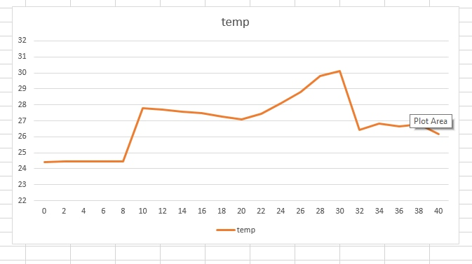

Figure 2: A graph of temperature from MLX90614 temp sensor

**Temperature from ABAQUS simulation**

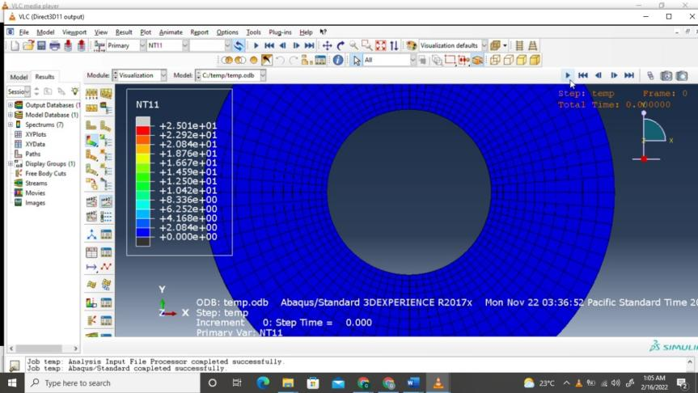

Figure 3: An Image of the temperature simulation using Abaqus before the drilling process starts

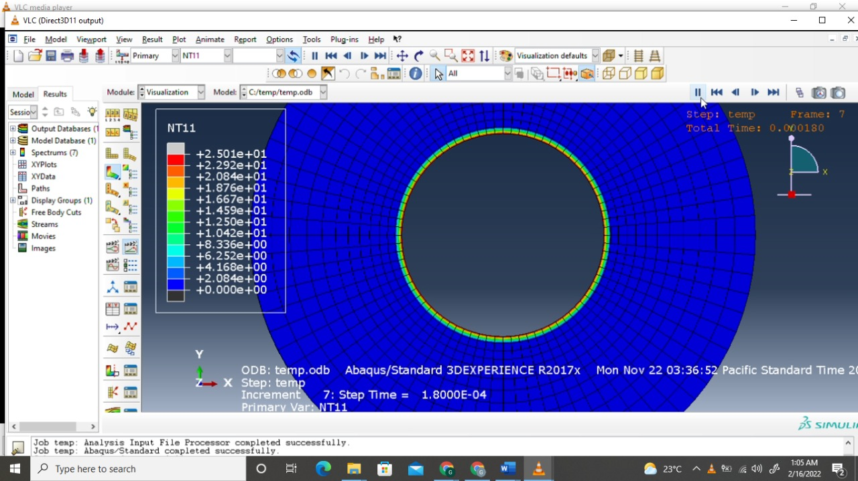

Figure 4: An image of the workpiece in Abaqus temperature simulation during the drilling process

**Expected Vibration output from 801S Vibration sensor**

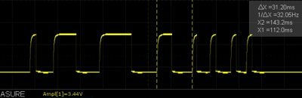

Figure 5: 801S Vibration sensor expected output

Its output switches shortly from LOW to HIGH depending on the vibrations during the drilling process. A threshold value was set on the onboard potentiometer where drilling was safe.

**Hole Quality**

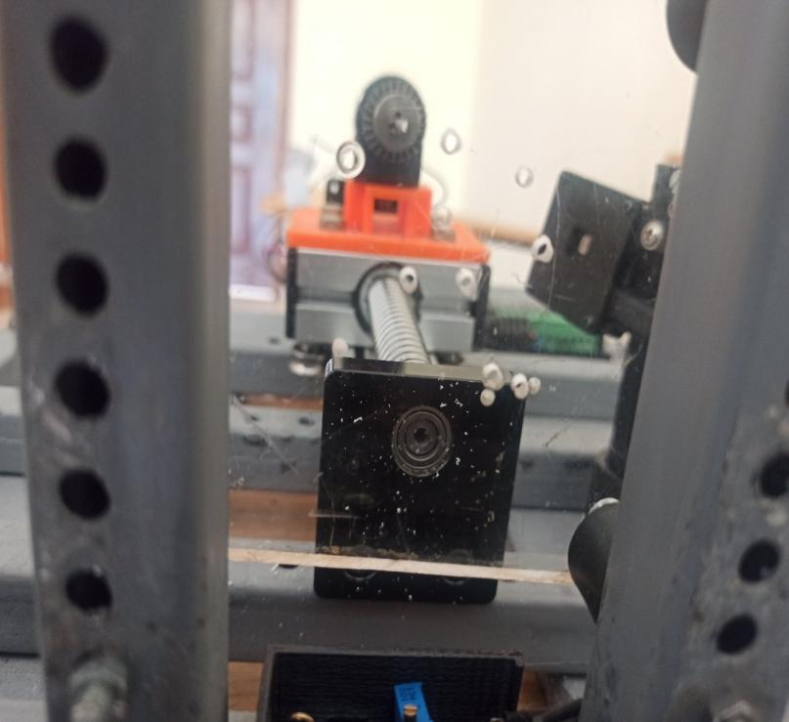

Figure 6: An Image of the PMMA Workpiece showing different holes

1. **DISCUSSION**

The drilling speeds were achieved with (Pulse Width Modulation) PWM by the Arduino Mega 2560. The motor had a maximum (Revolutions per Minute) RPM of 12000, which in turn, correlated which a maximum setting of 255 on PWM. We used different RPM according to the drill bit diameter in order to ensure we achieved quality holes.

We also had another parameter to control which was the feed rate (mm/rev). This is the velocity at which the cutter is advanced against the workpiece. This was being controlled by the stepper motor.

The following are the drilling parameters that were achieved to produce quality holes on the PMMA sheet.

During the drilling process, we were monitoring vibrations and temperature to ensure optimal parameters that would lead to quality holes. The temperature was being monitored by the MLX 90614 temperature sensor while the vibrations were being monitored by the 801S vibration sensor.

Temperature from Abaqus simulations matched with the actual results from the experiment as predicted.

1. **CONCLUSIONS**

* The automated drill was able to drill as expected, and the parameters for optimum drilling were determined for production of quality holes.
* Temperature and vibration were able to be monitored during the drilling process.
* The vibration signals are considered to contain reliable features for monitoring drill wear and breakage.
* It is also time effective, inexpensive and easy to use.

**RECOMMENDATIONS**

We would recommend that if the project is to be improved, there should be:

* An introduction to feedback control
* Making the project smart such as use of a Bluetooth module to operate it from a remote position.
* Introducing another axis.

**REFERENCES**

1. Brandrup J, Immergut EH, Grulke EA, editors. Polymer Handbook. 4th ed. New York: John Wiley & Sons; 1999
2. Ulrich H. Introduction to Industrial Polymers. Munich: Hanser; 1982
3. Rey-Vinolas S, Engel E, Mateos- Timoneda MA. Polymers for bone repair. In: Bone Repair Biomaterials. Woodhead Publishing Series in Biomaterials. UK: an imprint of Elsevier; 2019. pp. 179-197. DOI: 10.1016/ b978-0-08-102451-5.00007-x
4. Modelling and optimization of temperature in orthopaedic drilling: An in vitro study RUPESH KUMAR PANDEY, SUDHANSHU SEKHAR PANDA
5. <https://www.researchgate.net/publication/232167295_Finite-Element_Analysis_of_Forces_in_Drilling_of_Ti-Alloys_at_Elevated_Temperature>
6. Finite Element Analysis of Drilling Frame on Down-the-Hole Drill Based on Mechanical Mechanics and Mechanical Properties | Scientific.Net : <https://www.scientific.net/AMR.908.282>
7. (PDF) 3D Finite Element Modelling of Drilling Process: <https://www.researchgate.net/publication/317271692_FEM_Simulation_of_Tool_Wear_in_Drilling>

.